How to Set Up a VPN

# What is VPN?

A Virtual Private Network, more often known as VPN, is a service that provides a secure tunnel between your device and the internet. With the help of a VPN you can carry out a secure online transaction. In addition to providing a secure encrypted data transfer, VPNs are also used to disguise your whereabouts and give you access to regional web content.

# Why Use a VPN?

Whether you’re focused on online privacy, data security, or accessing restricted content, a VPN can offer substantial benefits.

1. Online Privacy: A VPN hides your IP address and physical location, making your online activities nearly untraceable. This is crucial for maintaining anonymity and protecting your data from advertisers, ISPs, hackers, and even government surveillance. Choosing a VPN with a strong no-logs policy ensures that your online actions are kept private, as there is no data trail left behind.
2. Secure Data Transfer: VPNs encrypt your internet traffic, which protects your data from hackers, especially when using unsecured networks like those in airports or coffee shops. Originally designed to facilitate safe corporate data exchanges, VPNs are now essential for securing your personal information online.
3. Bypassing Geographical Restrictions: If you face region-specific restrictions on websites or streaming services, a VPN can help you bypass these barriers. By connecting to a server in a different location, you can access content that’s otherwise unavailable in your region. This includes streaming services and various online markets.
4. Improving Gaming Ping: For gamers, a VPN can help reduce ping issues by connecting to a server closer to your game server, which can enhance your gaming experience and offer better performance.

# Setting Up a VPN in Windows 11

A Virtual Private Network (VPN) enhances your online privacy by creating a secure connection to another network over the Internet. This document will guide you through the process of setting up a VPN on a Windows 10 computer.

## **Prerequisites**

1. Windows 11 computer
2. VPN service credentials (username, password, server address)

## **Step-by-Step Instructions**

### **Step 1: Open VPN Settings**

1. Click the **Start** button.
2. Select **Settings** (gear icon).
3. Go to **Network & Internet**.
4. Click **VPN**.

### **Step 2: Add a VPN Connection**

1. Click the **Add VPN connection** button.
2. Fill out the fields as follows:
   1. **VPN provider**: Select "Windows (built-in)".
   2. **Connection name**: Enter a name for the VPN connection.
   3. **Server name or address**: Enter the VPN server address.
   4. **VPN type**: Choose the appropriate type (e.g., L2TP/IPsec).
   5. **Type of sign-in info**: Select "Username and password".
3. Enter your **username** and **password**.
4. Click **Save**.

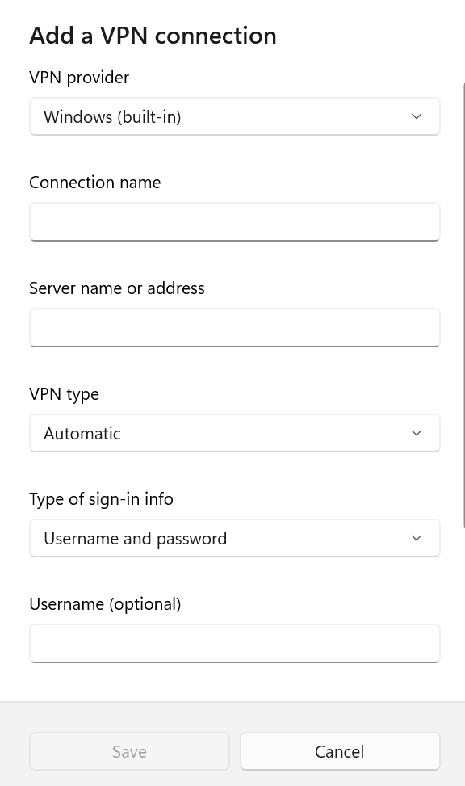

### **Step 3: Connect to the VPN**

1. Click the VPN connection name you created.
2. Click **Connect**.
3. Verify the status shows "Connected."
4. You can add VPN icon at your task bar and add on your day.

# **Troubleshooting Tips**

1. Incorrect credentials: Check your username, password, and server address.
2. Connection fails: Restart your computer and reconnect.
3. Server issues: Try connecting to a different VPN server.

# Facts and Queries

#### **1. Is using a VPN legal?**

**Answer**: In most countries, using a VPN is legal. However, some countries, like China and Russia, restrict or ban VPN usage.

#### **2. Will a VPN slow down my internet speed?**

**Answer**: Yes, a VPN can reduce your internet speed due to the encryption process and the distance between your device and the VPN server.

#### **3. Can I use a VPN on my smartphone?**

**Answer**: Yes, VPNs are available for smartphones and can be installed as apps on both Android and iOS devices.

#### **4. Do all VPNs offer the same level of security?**

**Answer**: No, the level of security depends on the VPN provider, the protocol used, and the server's location.

#### **5. Can a VPN be hacked?**

**Answer**: While VPNs are designed to be secure, they are not immune to hacking. However, using a reputable VPN with strong encryption significantly reduces the risk.

#### **6. What is the difference between a free VPN and a paid VPN?**

**Answer**: Free VPNs often have limited features, bandwidth restrictions, and may log user data. Paid VPNs typically offer better security, no data caps, and more server locations.

# **Conclusion**

Setting up a VPN on Windows is straightforward with the built-in VPN client. Ensure that you use the correct credentials and server details provided by your VPN service. Always disconnect the VPN when not in use to maintain optimal network performance.